# Web Technologies project support worksheet 4

# Copying the HTML

Go to the ACW2 project link in the Unit Assessment section of the Web Technologies Moodle entry. Now from the Homepage, go to the view source function (from Chrome on a PC this is **Control U**). This will display the HTML code for that page:

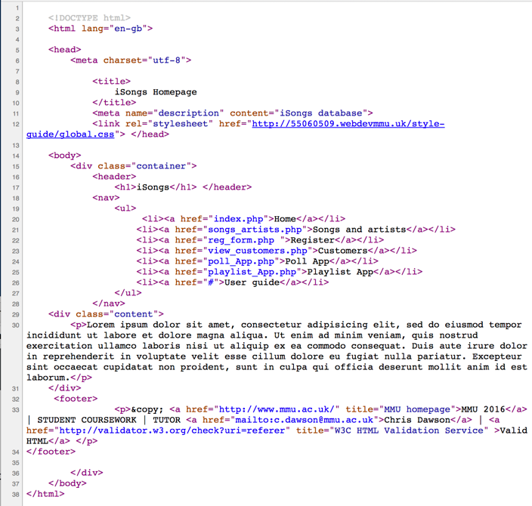

Select and copy this code and save as **template.html**.

# Creating includes

Now, using the technique you have learned during the week 5 session on includes, create **header.php** and **footer.php** files from the **template.html** file as **includes**. Next, create an index page (**index.php**) containing the middle section of the document.

You should be able to see something like this:

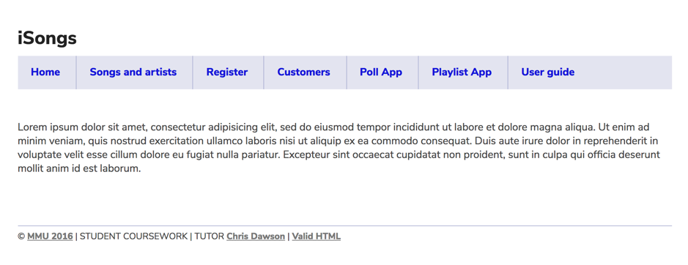

Now, create two more pages e.g. **poll_App.php** and **playlist_App.php**, from the above navigation list, with each page deriving its header and footer code from includes. You can keep the placeholder text (Lorem ipsum) for the time being.

# Creating includes

Adapt the page title in the header so that it is a variable, using the **$page_title** technique shown in section 4.2 of the worksheet for week 5. Next, add the variables to each page using the technique shown in the same worksheet.

# Testing the pages

Now test out the links between each page. If you have created the new files correctly, they should all work. Also, check that the page titles match the pages.

# Comments

Add a PHP comment to the echo statement in the **header.php** and to the title variable **index.php**